Temperature sensor LM35 Interfacing to Arduino:

Introduction:
LM35 is a simple temperature sensor. LM35 has 3 pins. Refer to the following image for the pin mappings

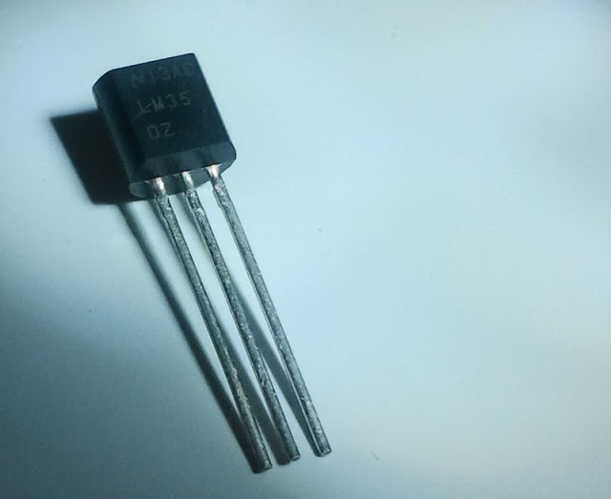

Requirment:
- LM35
- Arduino Board
- Breadboard

Hardware configuration:
The LM35 pin mapping as shown given below.

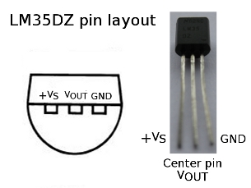

Step1: Place the LM35 sensor in breadboard.
Step2:Connect Wires to Supply & Ground. Take a wire from the middle pin and connect it to Analog In 2 of the Arduino.

Programing:(source code):

Programming to control the LM35 temperature Sensor:

float temp;
int tempPin = 0;
void setup()
{
Serial.begin(9600);
}
void loop()
{
temp = analogRead(tempPin);
emp = temp * 0.48828125;
Serial.print("TEMPRATURE = ");
Serial.print(temp);
Serial.print("*C");
Serial.println();
delay(1000);
}
Installation:
The source code copy to the skeches of arduino and compile (there is verify option) as shown given below.
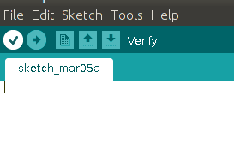

And then uploding the source code.(there is uploding option) to the Arduino board.(software) as shown given below.
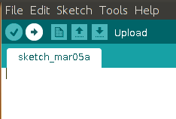

Troubleshooting:
FAQ:
Maintainers:
Duryodhan Aldar (durva.ges@gmail.com)

References: http://quickstartkitforarduino.blogspot.in/

